1. **Deploy a Python Flask App using Docker**

**Step 1: Jenkins Pipeline**

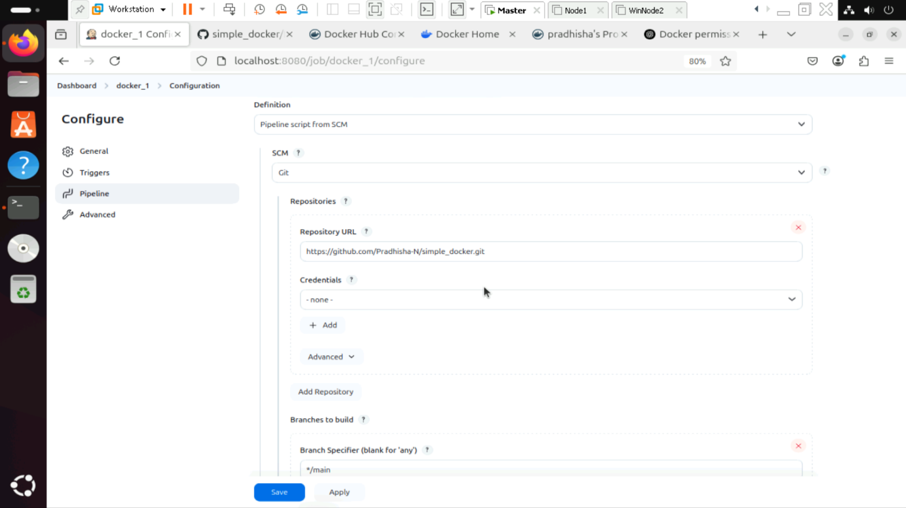

**Step 2 : Save the Pipeline**

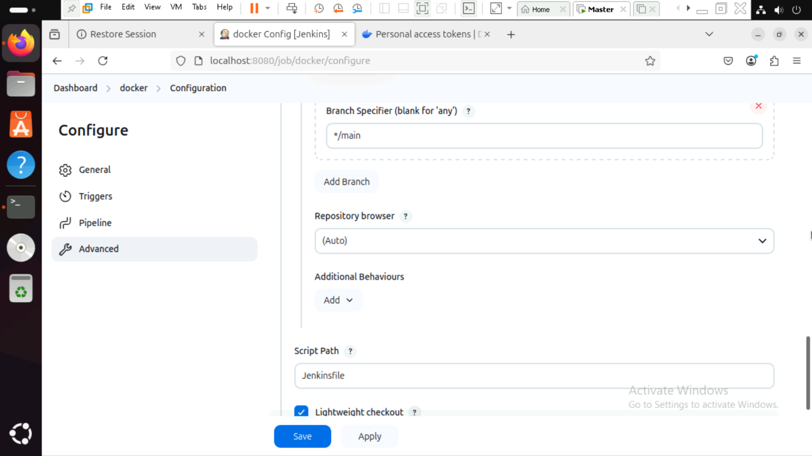

**Step 3: Build and run the docker container**

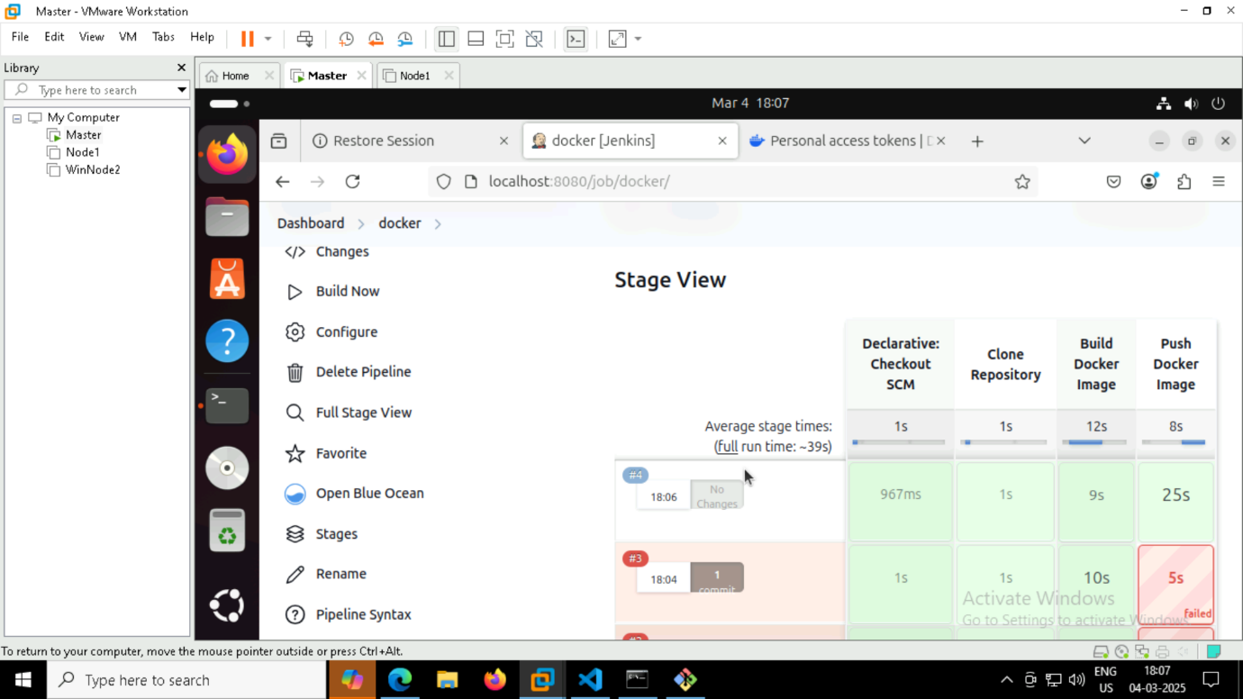

**Step 4: Push the docker files to Github**

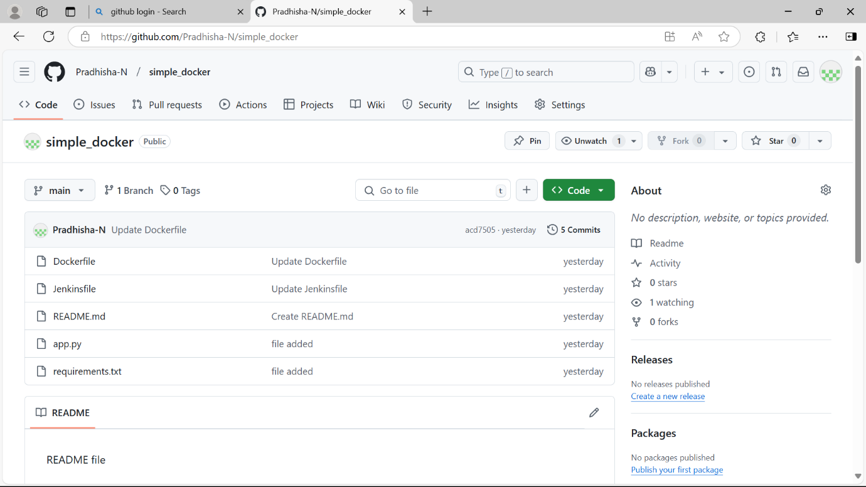

**Step 5: Output**

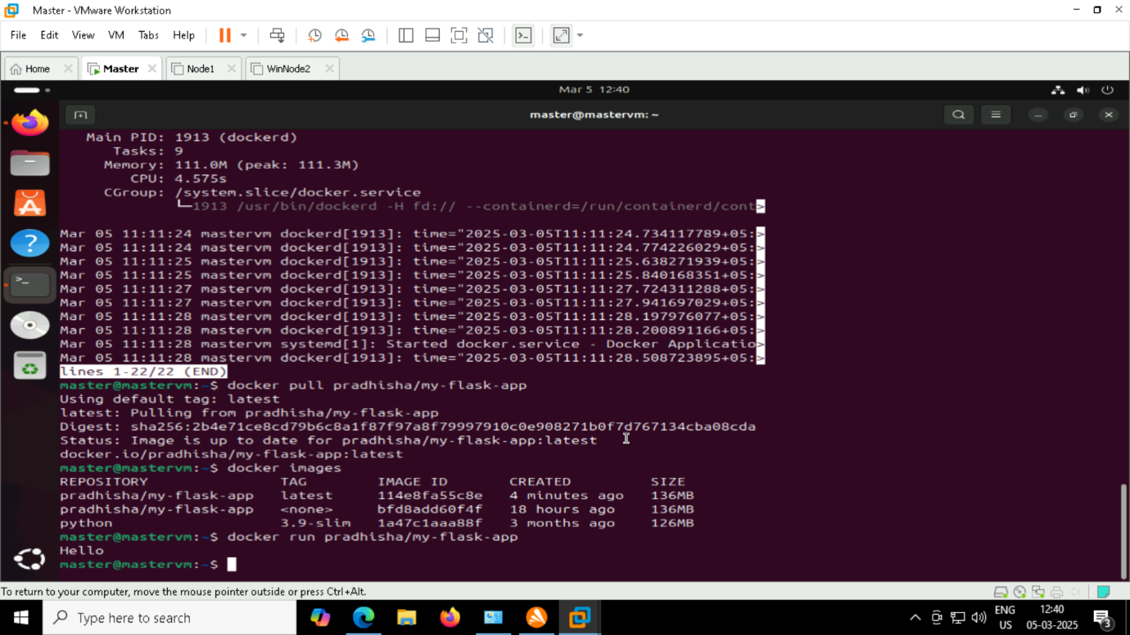

1. **Installing and enabling docker inside ubuntu terminal**

Step 1: sudo apt upgrade -y

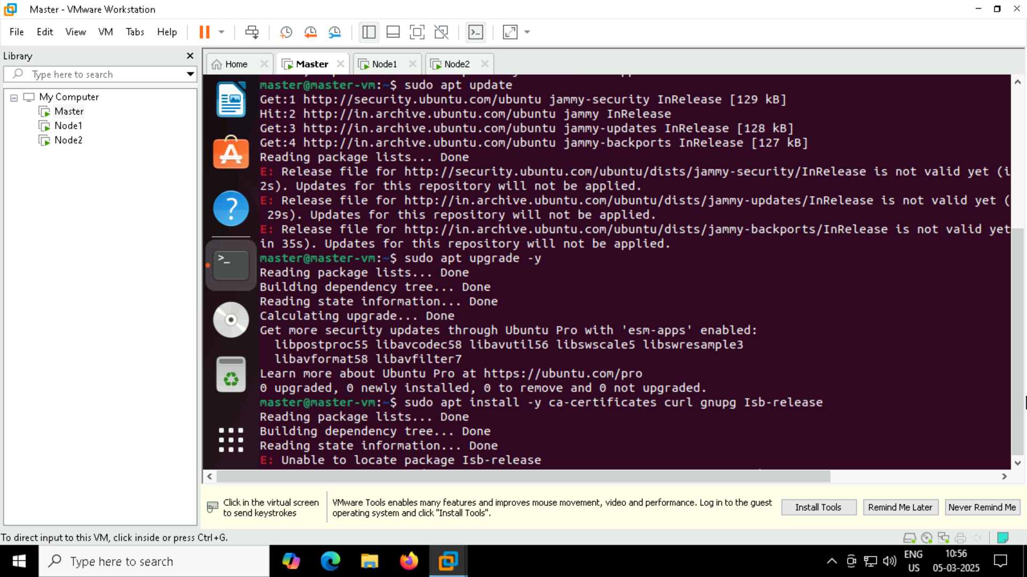

Step 2 : sudo apt install -y ca-certificates curl gnupg lsb-release

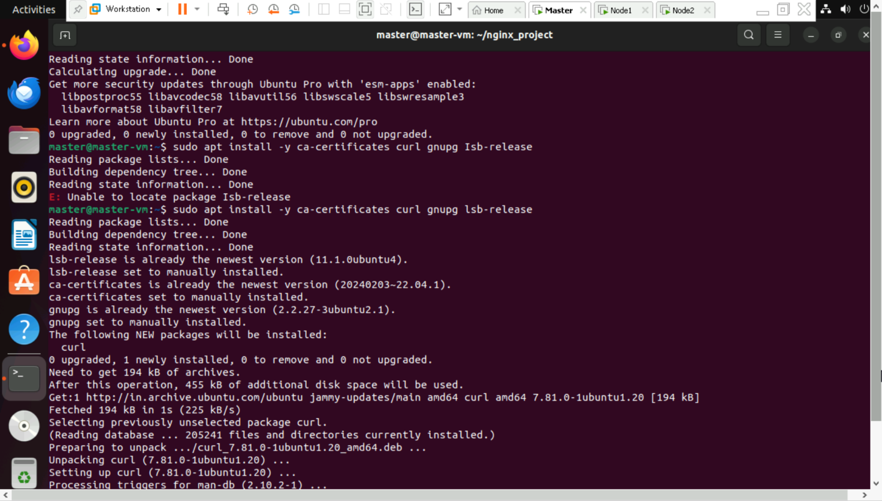

Step 3 : sudo mkdir -p /etc/apt/keyrings

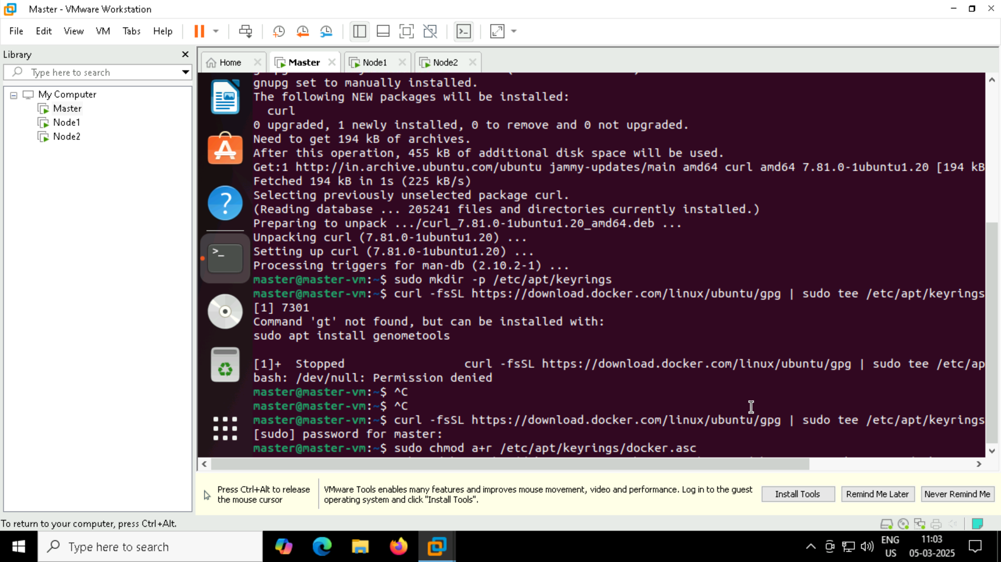

Step 4 : curl -fsSL https://download.docker.com/linux/ubuntu/gpg | sudo tee /etc/apt/keyrings/docker.asc > /dev/null

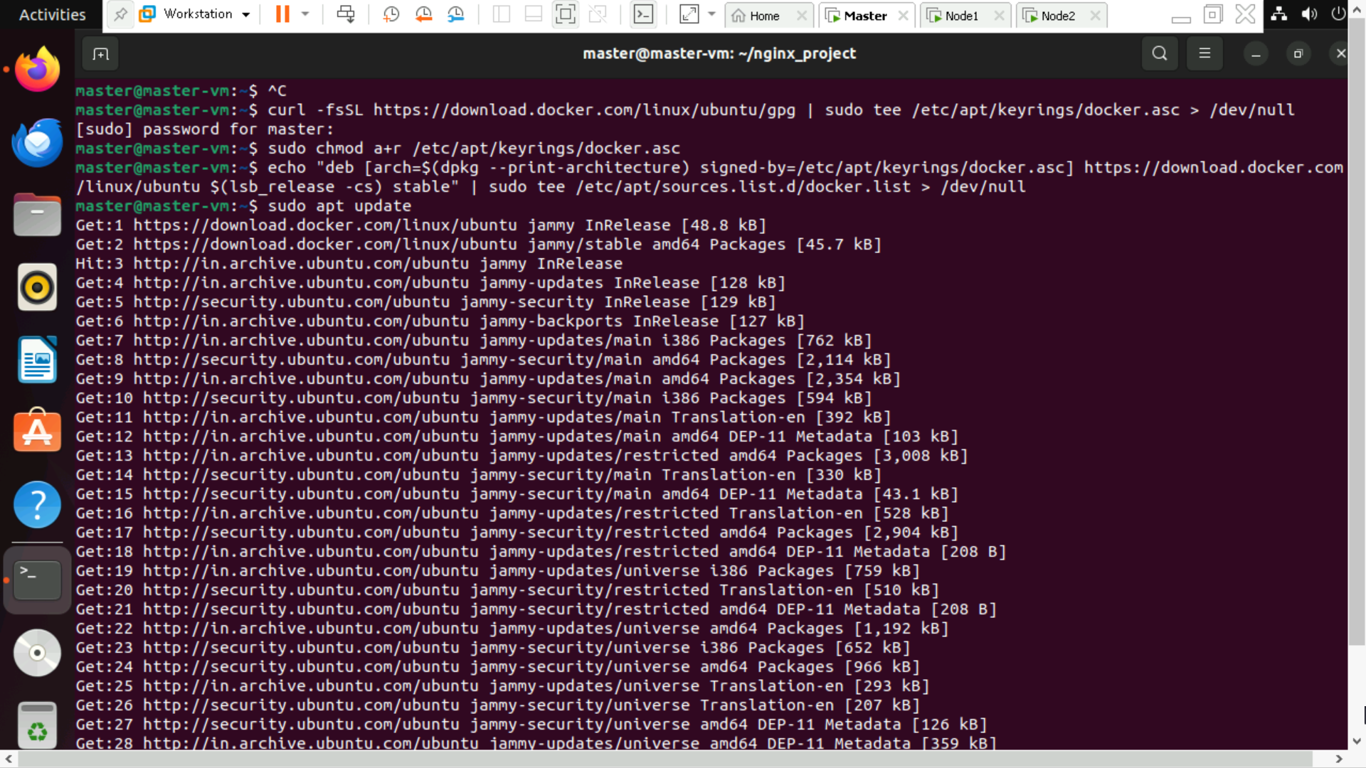

Step 5 : sudo chmod a+r /etc/apt/keyrings/docker.asc

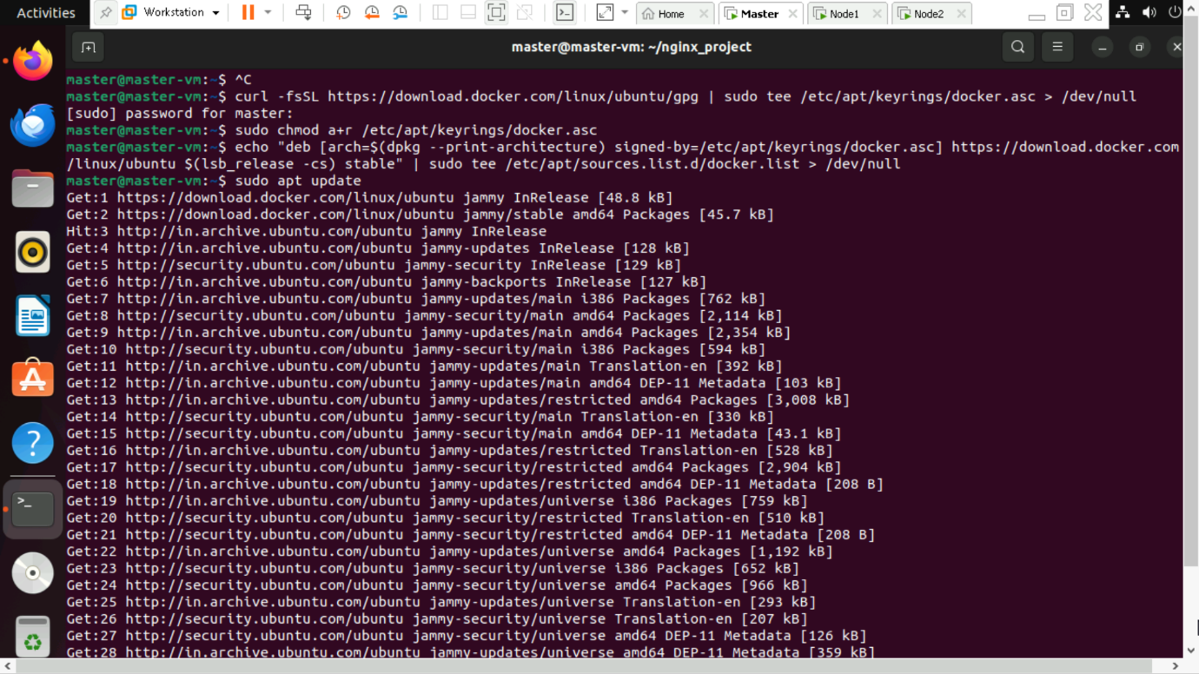

Step 6 : echo "deb [arch=$(dpkg --print-architecture) signed-by=/etc/apt/keyrings/docker.asc] https://download.docker.com/linux/ubuntu $(lsb_release -cs) stable" | sudo tee /etc/apt/sources.list.d/docker.list > /dev/null

Step 7 : sudo apt update



Step 8 : sudo apt install -y docker-ce docker-ce-cli containerd.io docker-buildx-plugin docker-compose-plugin

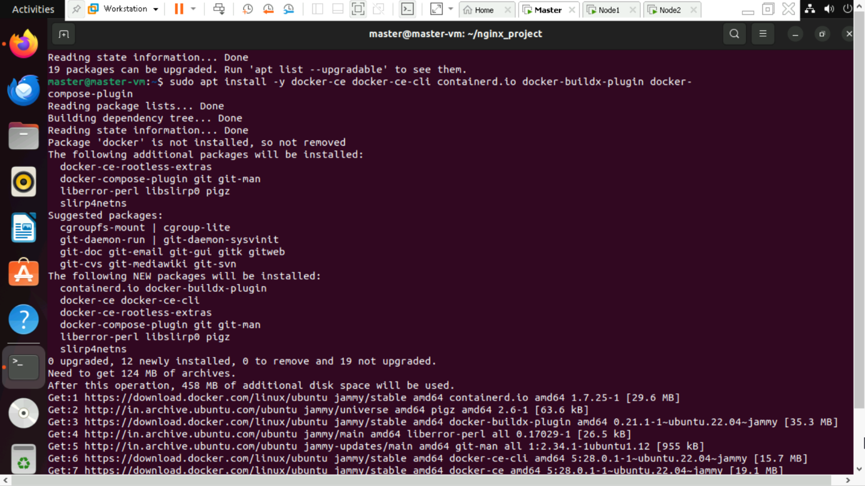

Step 9 : sudo systemctl start docker

Step 10 : sudo systemctl enable docker

Step 11 : sudo docker --version

Step 12 : sudo usermod -aG docker $USER

Step 13 : newgrp docker

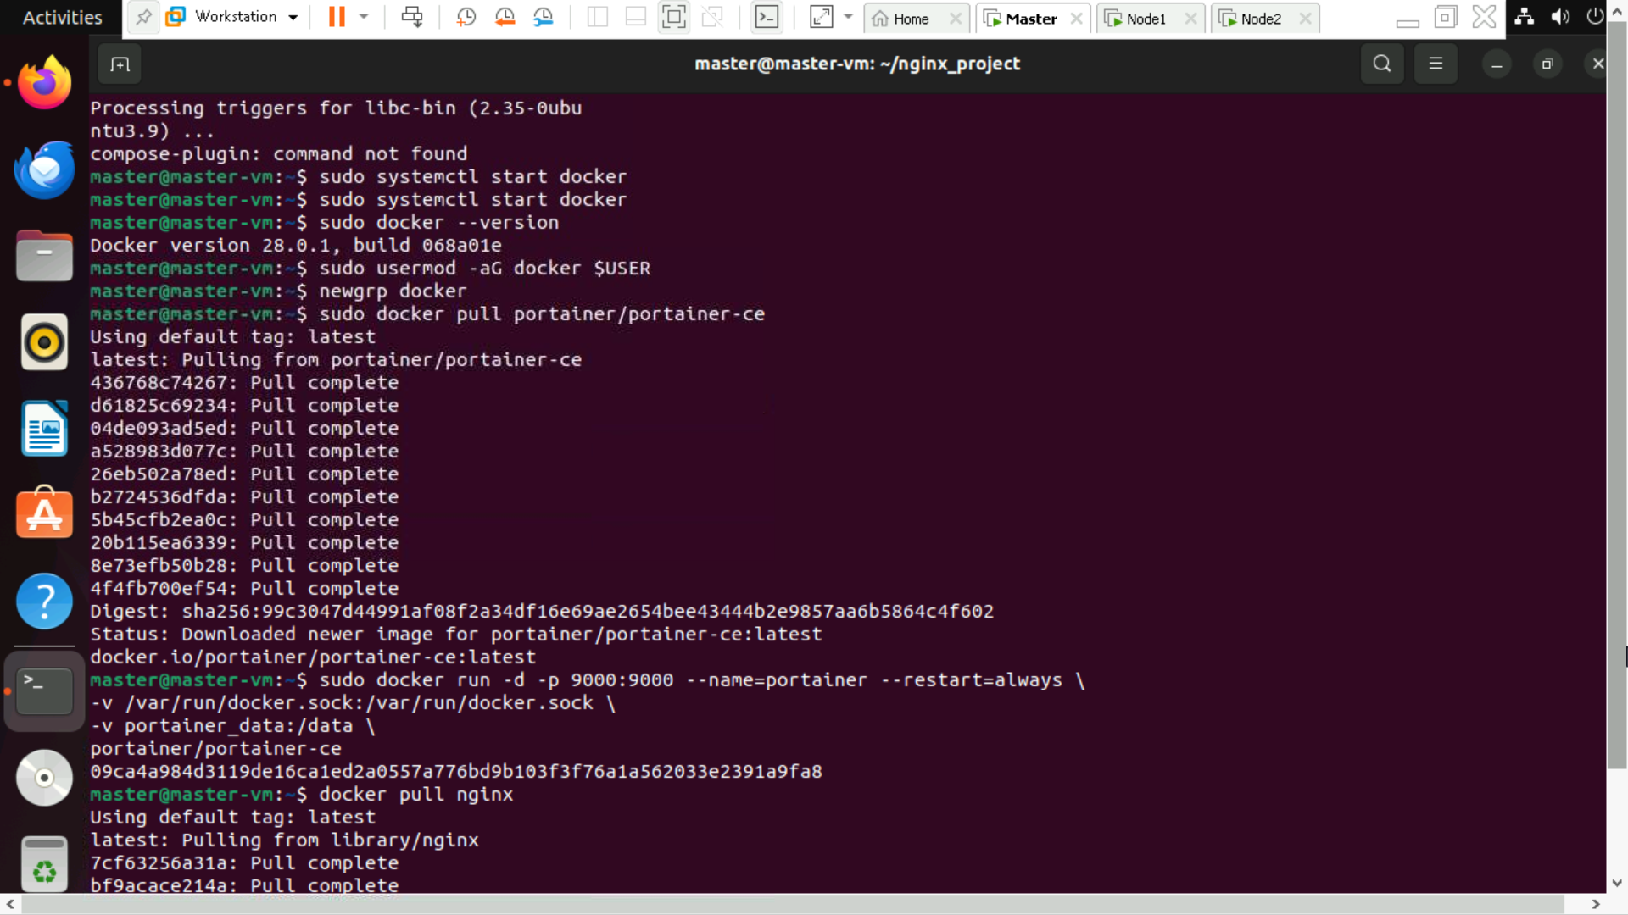

**Connecting ubuntu terminal with GUI based portainer**

Step 1 : sudo docker pull portainer/portainer-ce

Step 2 : sudo docker run -d -p 9000:9000 --name=portainer --restart=always \-v /var/run/docker.sock:/var/run/docker.sock \-v portainer_data:/data \portainer/portainer-ce

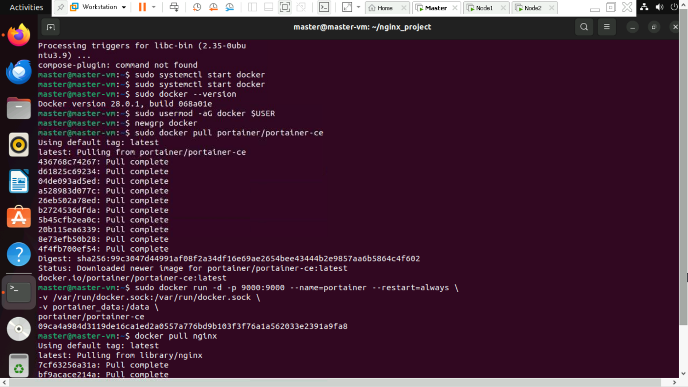

Step 3 : go to http://localhost:9000 and enter password

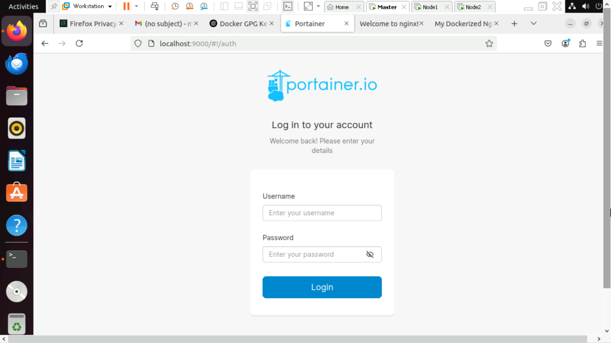

**Deploy an Nginx Web Server with Docker**

Goal: Run an Nginx server using Docker.

Prerequisites: Install Docker

**Step 1: Pull the Nginx Image**

Run the following command to pull the official Nginx image:

docker pull nginx

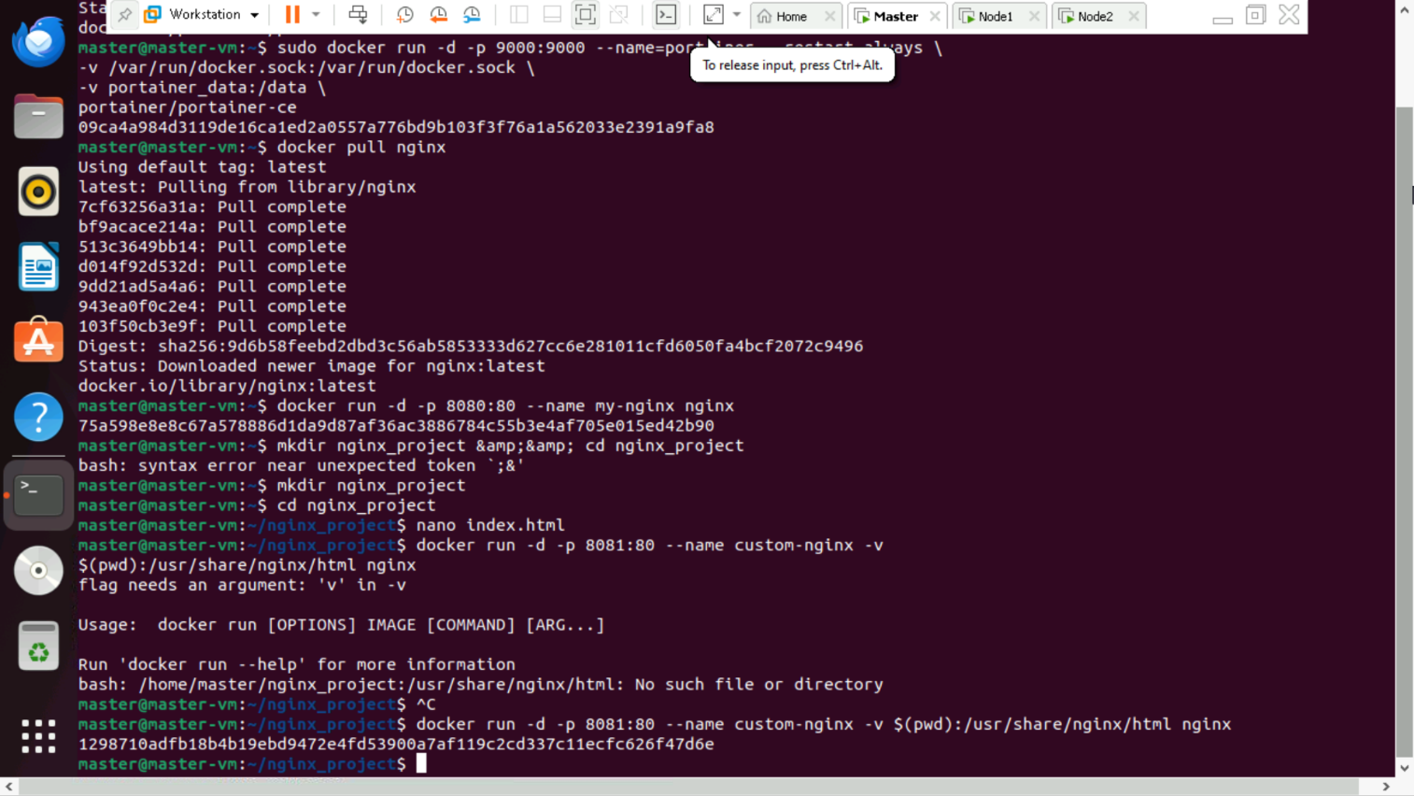

**Step 2: Run an Nginx Container**

Start a container and map port 80 to access it from your browser:

docker run -d -p 8080:80 --name my-nginx nginx

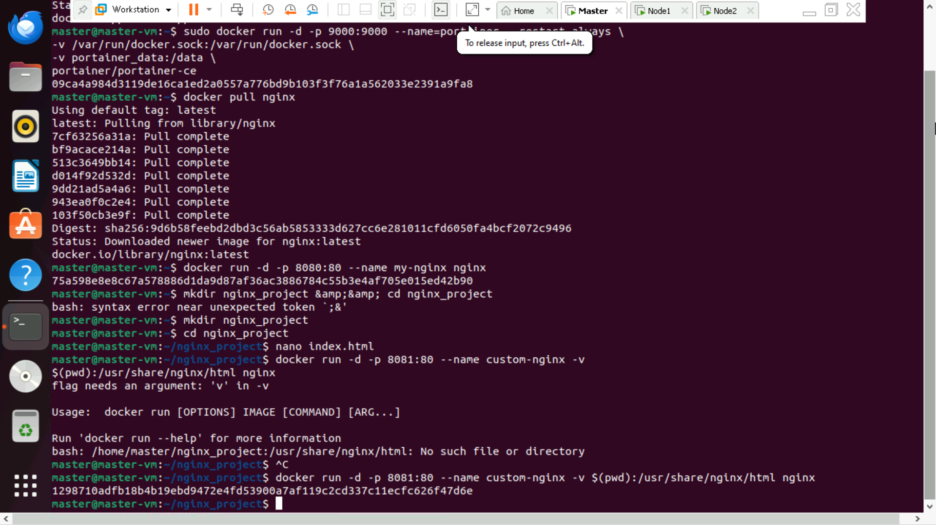

Now, open http://localhost:8080 in your browser, and see the Nginx welcome page.

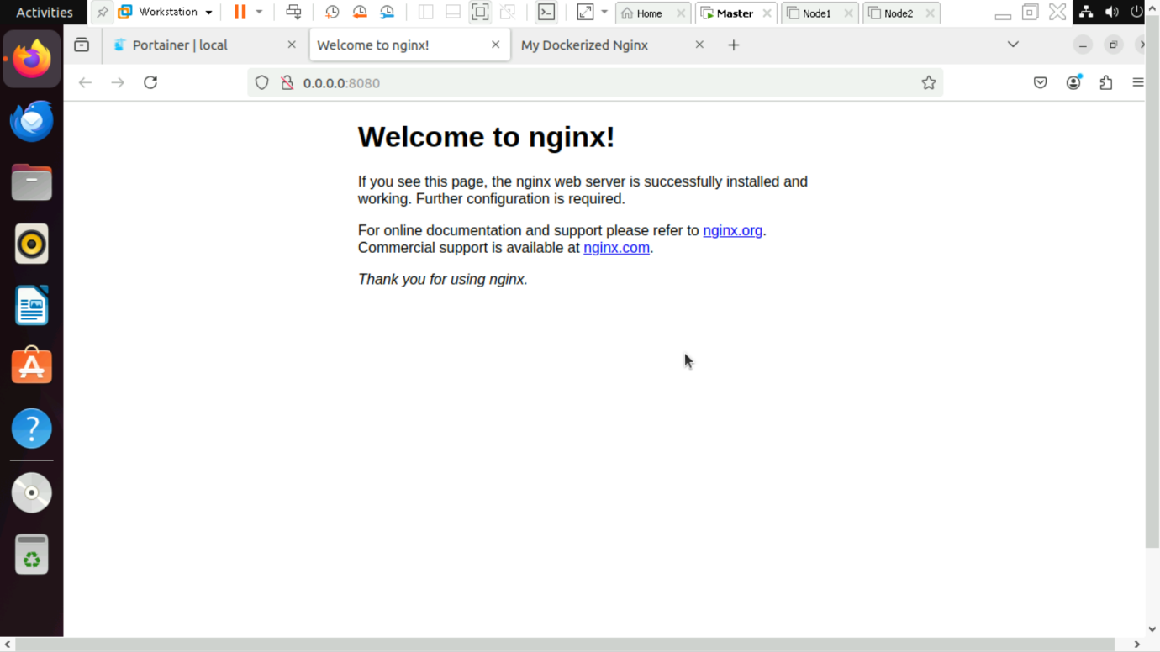

**Step 3: Customize Nginx with Your Own HTML Page**

Create a directory for your Nginx files:

mkdir nginx_project && cd nginx_project



Create an index.html file inside this directory:

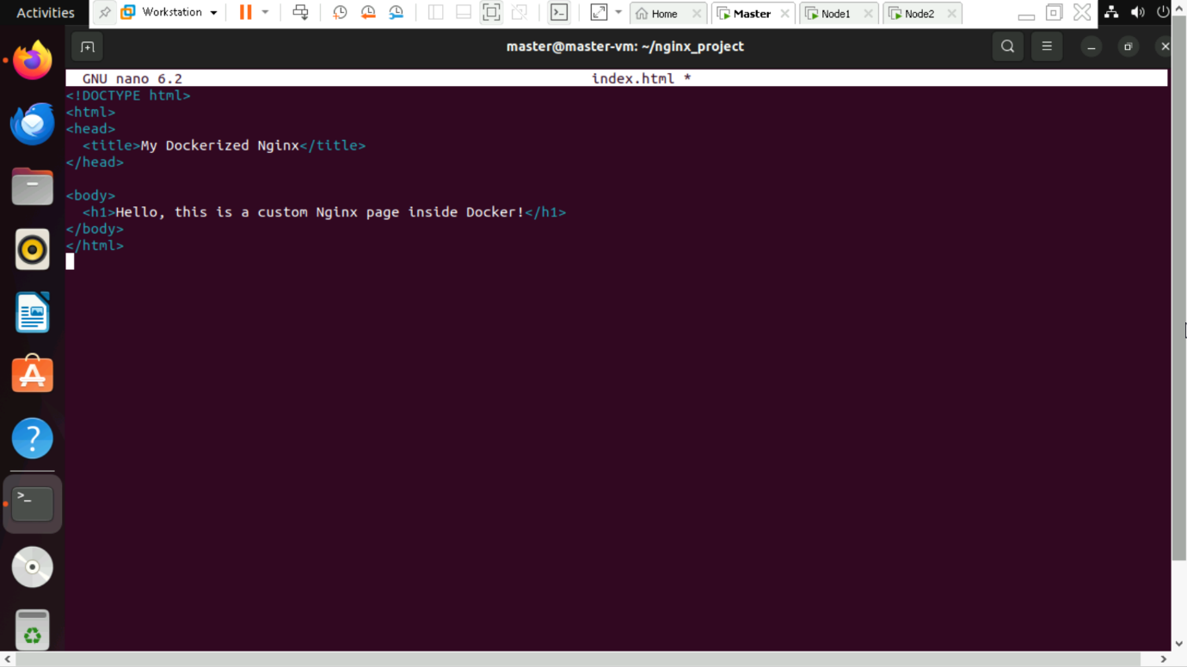

Run a new Nginx container with your custom HTML page:

docker run -d -p 8081:80 --name custom-nginx -v $(pwd):/usr/share/nginx/html nginx



Refresh http://localhost:8081, and see the custom page

